CHAPTER 1
INTRODUCTION
  - GENERAL
Environmental conditions and activities in and outside the tunnels can lead to deterioration of tunnel assets such as liner cracking, dislocated joints or even collapsed sections over an extended period. Leaks from sewer tunnels may contaminate the surrounding land and pose risks to public health. In order to prolong the service life of sewers and to protect surrounding environment, inspecting the structural integrity of the tunnel is an essential part of infrastructure maintenance.
The use of robots is one of the options being explored to assess underground spaces and to achieve enhanced inspection and maintenance capabilities. This option is desirable as it reduces the risk to humans resulting from prolonged incursions into a hazardous environment. The presence of biological contagions, hazardous and explosive gases (predominantly hydrogen sulphide, methane etc.) can pose a threat to the wellbeing of humans. Oxygen deprivation, absence of illumination and slippery conditions can further add to the risk level. In addition, automation promises greater reliability and manpower savings.
Deploying robots into modern-day sewer systems are not without its engineering and technological challenges. Frequently there are restrictions to access through manhole openings. Access tunnels may have further structural obstructions to permit the use of launch support mechanisms. In addition, the depth of service tunnels approaches 50 m with distances between adjacent accesses points approaching 2 km. Keeping the robots supplied with power is challenging and with conflicting operational advantages and disadvantages between on-board battery and surface supplied power.
The use of robotics systems in the construction field had been a common research area, and several studies review the advantages in the use of robotic platforms for construction [1][2] and underground construction [3] purposes. Robotic systems can complete the inspection process with objective results and high efficiency. They also improve safety by performing inspection in dangerous environments instead of the inspectors. They operate under real-world and real-time constraints where sensors and effectors with specific physical characteristics have to be controlled [4]. In many cases, those robots are controlled manually to move from one destination to another. However, a number of studies have been carried out on autonomous robots leading to a whole panoply of potential applications of these autonomous robots.
ATVs are vehicles used mainly for recreation and have increasing popularity
worldwide even though many injuries are caused by them [3][4]. Current researchers have
improved certain safety aspects of the ATVs, for example is the rollover prevention [5] which is
proven and applied on bicycle model. A device to control rollover is also designed based on
predictive functional control [6]. This approach is demonstrated successfully on the simulation test
bed. The rollover indicator of ATV is also can be estimated from the tire stiffness observer [7].
Other researchers also improved the control of ATV by using autonomous control [8][9]. While the
control schemes are successfully minimize the ATV accidents, the feeling and pleasure of riding an
ATV are reduced by the autonomous system itself. ATVs are also studied in term of dynamic
performance for some interested researchers. Such studies are the simulation of the ATV steering
system [10] and estimation of ATV dynamic parameters [11]. Designing and modeling of ATV are
important for the development of ATV itself. Available software such as CATIA [12] is used in the
digital development of ATVs and their components [13][14][15]. The advantage of using computer
aided design (CAD) software to design the ATV is proven by the simple fitting and assembly
virtually [16]
ATVs are vehicles used mainly for recreation and have increasing popularity
worldwide even though many injuries are caused by them [3][4]. Current researchers have
improved certain safety aspects of the ATVs, for example is the rollover prevention [5] which is
proven and applied on bicycle model. A device to control rollover is also designed based on
predictive functional control [6]. This approach is demonstrated successfully on the simulation test
bed. The rollover indicator of ATV is also can be estimated from the tire stiffness observer [7].
Other researchers also improved the control of ATV by using autonomous control [8][9]. While the
control schemes are successfully minimize the ATV accidents, the feeling and pleasure of riding an
ATV are reduced by the autonomous system itself. ATVs are also studied in term of dynamic
performance for some interested researchers. Such studies are the simulation of the ATV steering
system [10] and estimation of ATV dynamic parameters [11]. Designing and modeling of ATV are
important for the development of ATV itself. Available software such as CATIA [12] is used in the
digital development of ATVs and their components [13][14][15]. The advantage of using computer
aided design (CAD) software to design the ATV is proven by the simple fitting and assembly
virtually [16]
ATVs are vehicles used mainly for recreation and have increasing popularity worldwide even though many injuries are caused by them. Current researchers have improved certain safety aspects of the ATVs, for example is the rollover prevention which is proven and applied on bicycle model. A device to control rollover is also designed based on predictive functional control. This approach is demonstrated successfully on the simulation test bed. The rollover indicator of ATV is also can be estimated from the tire stiffness observer. Other researchers also improved the control of ATV by using autonomous control. While the control schemes are successfully minimizing the ATV accidents, the feeling and pleasure of riding an ATV are reduced by the autonomous system itself. ATVs are also studied in term of dynamic performance for some interested researchers. Such studies are the simulation of the ATV steering system and estimation of ATV dynamic parameters. Designing and modeling of ATV are important for the development of ATV itself. Available software such as CATIA is used in the digital development of ATVs and their components. The advantage of using computer aided design (CAD) software to design the ATV is proven by the simple fitting and assembly virtually.

  - OBJECTIVE OF THE PROJECT
The implementation of this design enables the robot to detect harmful gases and navigate through tunnels and pipelines with ease. The aim is to build a gas inspection robot which navigates through tunnels and pipes and estimate the gas level in it. This mobile robot tells us whether the tunnel environment is safe or not. An android app is developed which controls the navigation system of the bot using a Wi-Fi module and a live stream video footage from the integrated camera on the bot. This shall enable us to remotely access the bot and explore the tunnel. Gas sensors are mounted on the bot to collect different gases that are present within the tunnels.

  - ORGANIZATION OF THE PROJECT REPORT
The project report is organized as follows;
Chapter 1 deals with the introduction about the project and presents an overview of the basic concepts of gas inspection robot.
Chapter 2 deals with the Literature survey
Chapter 3 presents Hardware and Software description and prototype of the proposed system
Chapter 4 discusses the Experimental setup and Results
Chapter 5 offers conclusions and recommendations for future research.
CHAPTER 2
LITERATURE SURVEY
2.1 INTRODUCTION
This chapter gives an overview of existing similar systems and highlights the techniques and algorithms used in terrain vehicles. These vehicles have been in the attention of a number of researchers for quite some time
2.2. EXISTING METHODS
Several researches have been carried out in the field for effective detection of gas leakage. Yan and Rahayu developed a gas leakage detecting system which needs to be placed in a certain place and cannot move [6]. Although fitted gas sensors on different areas can be an approach for gas leakage detection however the method is very expensive, beside fitted gas detector cannot detect leakage unless the leakage is around the sensor therefore a moving sensor needs to take the job which is done by this robot [5]. This paper proposes a robot that can detect gas leakage and sends the data wirelessly to a receiving module consisting of a LCD display for monitoring the results.
Another model proposed by Supriyono and Hadi can effectively detect gas leakage but is restricted to be used in line following mode only [7]. As a result it cannot be sent in remote places where people have limited access to reach. In addition to this, it also lacks the ability to send continuous signals to the user in real time. However, the robot proposed in this work overcomes those limitations. Proposed robot can be operated in both line following and obstacle avoiding mode that made it distinctive from other robots. The dual mode feature and miniature size have made it unique and suitable to apply in gas detection especially in remote areas.
In Obstacle Avoiding Mode the robot can move freely through space avoiding any obstacles in its paths [8] [9]. It then sends the data about its surroundings wirelessly to the monitor, this mode can be used in places where the gas leakage needs to be checked inside a tunnels, vents or pipes where it is difficult for human to reach due to lack of space. The robot can be sent through this path and it can find its way through this path by its own without any predefined guidance by the user while at the same time sends signal wirelessly. On the other hand, in Line Tracking Mode the robot follows a particular drawn black line while doing so the robot detects any leakage within the surroundings and sends the signal to the receiving module, this mode can be used in situations where the robot needs to monitor gas leakage by following a specific predefined path well defined by the user. This mode can be used if the robot needs to monitor certain user defined tracks for a certain period of time without the need for any external human guidance.
Reference [10] paper deals with the Robot, which can directly track the location of the electrical fault in power cable by passing through the tunnels, and it sends its location updates to the system outside the tunnel. It has a system that passes a low-frequency signal through the cable and uses an Inductive magnetic field sensor that detects the magnetic field created around the broken wire and makes it easy to provide the exact location of the fault.
Reference [11] paper aims to find the faults, wear and tear of the wires in the underground tunnels. The same system is used to detect cracks in the oil pipelines. In their project we are implementing a robot which is capable of moving inside underground pipes and detecting cable faults and cracks in pipelines. Since the pipe gallery have very high pressure, temperature and toxic gases, which cannot be reached by humans, therefore a robot has been implemented that has a wireless camera, sensors which is used to detect the cable faults or crack and the conditions inside the pipe and it can be also used in oil refineries.
In paper [12], an embedded control system based on the ARM9 microprocessor S3C2410 is implementation for coal mine detect and rescue robot. Based on the design of robot's hardware, Linux operating system is ported as the platform of the software development. The embedded control system can achieve many tasks of the robot, such as motion control, environmental information acquisition, communication with the remote-control system and executing complex control algorithms. To address the special requirement, six tracks vehicle structure is adopted to enhance movement ability of the robot in the complex environment. Explosion proof, waterproof and dustproof design are also important features of the robot. Although its address several issues, the bulkiness of robot doesn’t enable it for operations in small diameter tunnels and pipelines.
The technology used in [13] – a rescue and security robot have a number of important features such as robotic car control by cell phone, automatically avoiding obstacles in its way. It can sense gas, smoke and provide an alert through text messaging. The robot can detect bombs, pick and place objects and also do distance measurements. A high-quality wireless video camera equipped with a stepper motor for the omni-directional view is used for the spying purpose which is mounted on the robot car to send real video images and audio signals. These audio and video stream received by the receiver unit can be used to take proper steps according to the received signals. This robot can also be used to reach places where humans cannot reach like hidden places, small tunnels. The ultimate focus of their system is to offer far possible security for the human being.
A number of algorithms and techniques that can be used for detecting obstacles which is an important component of autonomous navigation of inspection robot. These algorithms and techniques are briefly surveyed below.
The ranged-based and appearance-based obstacle detection technique [14] uses a combination of an ultrasonic sensor for distance measurement and a camera to calculate the size of the object. A camera, just as a human eye has a fixed field of view. Everything the camera sees will be squeezed into the image captured. Depending on how far an object is from the camera, will surely impact on its pixel size on the image. The ultrasonic sensor calculates the distance of the obstacle and using that distance combined with the angle of view of the webcam and the image resolution, the obstacle size is calculated.
The Sobel Edge Detection operator is a discrete differentiation operator, computing the approximation of the gradient of the image intensity function [15]. It is separated in two, the x and y directions kernel that are both 3 3 size matrices. To check for edges, both matrices are applied to each pixel in the image. The gradient of the image intensity at each point is calculated, giving the direction of the largest possible increase from light to dark and the rate of change in that direction. The result therefore shows how the image changes and how likely it is that this part of the image represents an edge and its orientation [16].
The Canny Edge Detector is an edge detection operator that uses a multi-stage algorithm to localize and minimize multiple responses to a single edge [17]. The input of the Canny operator is the output obtained from Sobel operator. After the gradient of each pixel and direction of edge have been obtained, the next step is to relate the edge direction to a direction that can be traced in an image. For a pixel p, there are only four possible directions when describing the surrounding pixels. It can be in the horizontal direction, along the positive diagonal, in the vertical direction or along the negative diagonal. Finally non-maximum suppression is used to trace along the edge in the edge direction and remove all the unnecessary pixels alongside the edge that make the latter thick in size into just one pixel width.
A thin line will be given as an output image. The Infrared Sensor is a device that has an IR transmitter and receiver [18]. It emits an infrared light using the transmitter, and when an obstacle is very close to the sensor, the light will bounce off the object and into the receiver. Depending on the distance between the obstacle and the sensor, the reflected light will have a different intensity. The module has on board potentiometer that lets user adjust detection range [19].
However different objects of different color or material will have a different effect on the reflected light even if they are all placed at the same distance from the sensor. In addition, there is no way to calculate the distance of the obstacle from the sensor and also, since this sensor uses infrared, the heat from sunlight will have an impact on the detection of the sensor, thus the sensor is not very accurate to be used outdoors but can perform well in indoor environments. The Ultrasonic Sensor is a device that can calculate the distance from an object by emitting a sound wave and measuring the time taken for it to bounce on the obstacle and come back [20,21].

2.3 CONCLUSION
The project finds intelligent design and development of systems to overcome the pros and cons of existing methods.

CHAPTER 3
HARDWARE DESCRIPTION
3.1 INTRODUCTION
This chapter deals with details of blocks present in the proposed module and also its design which is cited in the circuit diagram is specified in the following sections.
3.2 HARDWARE DESIGN
The block diagram describing the proposed system and its interconnection along with the stages involved is as described below.

ESP8266 NODEMCU
RASPBERRY PI
MQ2, MQ4
LIVE VIDEO FEED
192.168.43.203:9090/stream
PI CAMERA
POWER SUPPLY 1
MOTOR DRIVER
L298N
POWER SUPPLY 2
ANDROID APP
MOTORS

Figure 3.1 Block Diagram of the Proposed System
The proposed system consists of three major stages. Sensing stage, controlling and Communication stage. The Sensing stage consists of gas sensors (MQ2, MQ4). The signal received by the sensors is applied to NodeMCU which is the controlling and computing part of the system. The controlling stage involves navigating the bot inside the tunnel with the help of pi camera and app. The communication stage involves sending sensor values to the app. Thus, appropriate decisions can be taken by analyzing the gas distribution inside the tunnel.
3.2.1. Control Board
The proposed system uses two controlling devices for easy interfacing and cost-efficient methods to implement it under practical circumstances.
3.2.1.1. ESP8266 NODEMCU:
The proposed system consists of Arduino microcontroller, sensor unit and power supply. Arduino is an open-source platform used for building electronics projects. Arduino consists of both a physical programmable circuit board often referred to as a microcontroller and a piece of software, or IDE (Integrated Development Environment) that runs on a computer, used to write and upload computer code to the physical board.
The Arduino used here is ESP 8266 because multiple analog input sensors probes need to be connected with the Arduino board. It has a set of registers that function as a general-purpose RAM. It requires 5v power supply and has a clock speed of 16 MHZ. Special purpose control registers for on-chip hardware resources are also mapped into the data space. The addressability of memory varies depending on device series, and all PIC devices have some banking mechanism to extend addressing to additional memory. Later series of devices feature move instructions which can cover the whole addressable space, independent of the selected bank.

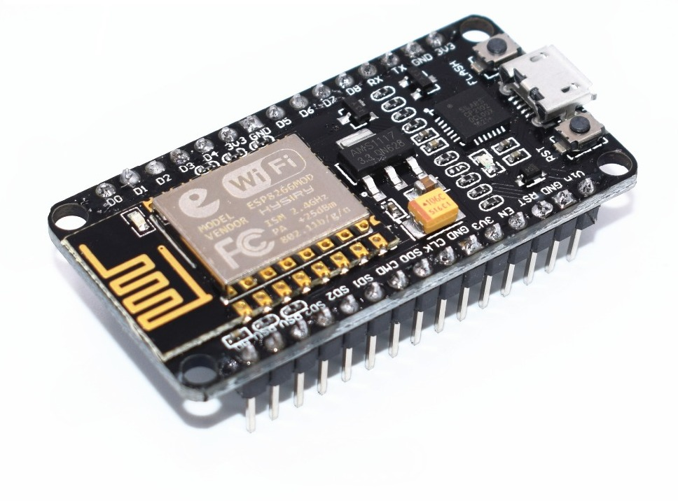

Figure 3.2 Arduino ESP 8266
NodeMCU is an open-source firmware and development kit that helps you to prototype or build IoT product. It includes firmware which runs on the ESP8266 Wi-Fi SoC from Espressif Systems, and hardware which is based on the ESP-12 module. The firmware uses the Lua scripting language. It is based on the eLua project, and built on the Espressif Non-OS SDK for ESP8266.
In earlier devices, any register move had to be achieved via the accumulator. Thus the mechanism functions with the help of coding inbuilt in the Arduino board. It is connected with computer through universal serial bus (USB) port and can store up to 256 KB of data. It has 54digital I/O pins and 16 analog input pins. Four sensors are connected to four digital/analog pin of Arduino. Figure 3.2 gives us an illustration of Arduino ESP8266 NODEMCU.
3.2.1.2. RASPBERRY PI
The Raspberry Pi is a series of small single-board computers developed in the United Kingdom by the Raspberry Pi Foundation to promote teaching of basic computer science in schools and in developing countries. The original model became far more popular than anticipated, selling outside its target market for uses such as robotics. It does not include peripherals (such as keyboards and mice) and cases. However, some accessories have been included in several official and unofficial bundles.
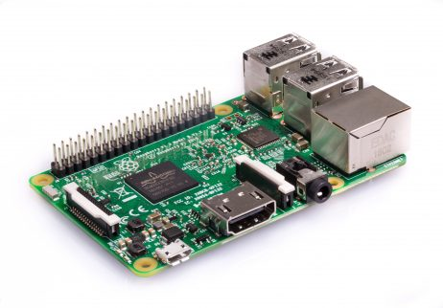
The Raspberry Pi 3 Model B is the earliest model of the third-generation Raspberry Pi. It has a Quad Core 1.2GHz Broadcom BCM2837 64bit CPU, 1GB RAM, BCM43438 wireless LAN and Bluetooth Low Energy (BLE) on board. It carries 40-pin extended GPIO, 4 USB-2 ports, composite video port, Full size HDMI and a CSI camera port for connecting a Raspberry Pi camera. A Micro SD port is present for loading the operating system and storing data.

Figure 3.3. Raspberry Pi Model-3B
The Raspberry Pi Foundation provides Raspbian, a Debian-based Linux distribution for download, as well as third-party Ubuntu, Windows 10 IoT Core, RISC OS, and specialized media center distributions. It promotes Python and Scratch as the main programming languages, with support for many other languages. The default firmware is closed source, while an unofficial open source is available. Many other operating systems can also run on the Raspberry Pi, including the formally verified microkernel, seL4. Other third-party operating systems available via the official website include Ubuntu MATE, Windows 10 IoT Core, RISC OS and specialized distributions for the Kodi media center and classroom management.

3.2.2. Sensors and other Devices for Monitoring
Two monitoring devices are used here for the sensing of Humidity and Temperature along with the direct video feed. The devices used are as follows.
3.2.2.1. PI-CAMERA
The Raspberry Pi Camera Module v2 replaced the original Camera Module in April 2016. The v2 Camera Module has a Sony IMX219 8-megapixel sensor. The Camera Module can be used to take high-definition video, as well as still photographs. It’s easy to use for beginners, but has plenty to offer advanced. Time-lapse, slow-motion, and other video processing is possible using this device. Libraries are available for interfacing the camera with the Raspberry Pi. The Raspberry Pi Camera Module v2 is a high quality 8 megapixel Sony IMX219 image sensor custom designed add-on board for Raspberry Pi, featuring a fixed focus lens.
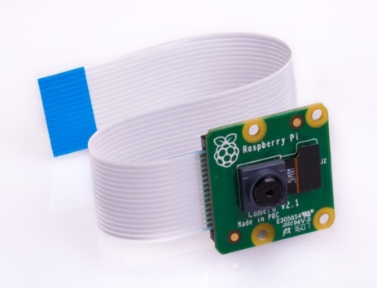

Figure 3.4. Pi-Camera
The Camera Module can be used to take high-definition video, as well as stills photographs. It supports 1080p30, 720p60 and VGA90 video modes, as well as still capture. It attaches via a 15cm ribbon cable to the CSI port on the Raspberry Pi.
3.2.2.2. GAS SENSORS:
- MQ 2 SENSOR:
The MQ-2 Gas sensor can detect or measure gasses like LPG, Alcohol, Propane, Hydrogen, CO and even methane. The module version of this sensor comes with a Digital Pin which makes this sensor to operate even without a microcontroller and that comes in handy when you are only trying to detect one particular gas. When it comes to measuring the gas in ppm the analog pin has to be used, the analog pin also TTL driven and works on 5V and hence can be used with most common microcontrollers.
Each MQ2 element is strictly calibrated in the laboratory that is extremely accurate on humidity calibration. The calibration coefficients are stored as programs in the OTP memory, which are used by the sensor’s internal signal detecting process. The single-wire serial interface makes system integration quick and easy. Its small size, low power consumption and up-to 20meter signal transmission making it the best choice for various applications, including those most demanding ones. The component is 4-pin single row pin package. It is convenient to connect and special packages can be provided according to users’ request.
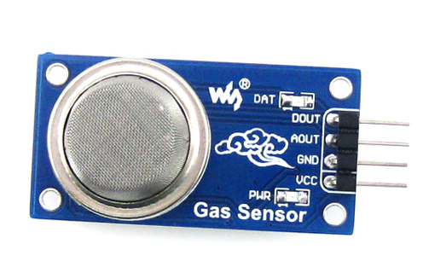
Figure 3.5. MQ2 SENSOR
Here we use the MQ2 sensor for monitoring the gas level of the surroundings where the bot is hovering with the Pi cam relaying the video feed live.
Table 3.1. Summary of Sensor specification
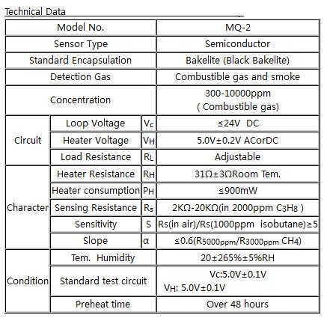
- MQ4 SENSOR:
MQ-4 gas sensor has high sensitivity to Natural gas, Methane and could be used to detect both Methane and Propane. The sensor could be used to detect different combustible gas especially Methane, its low cost and suitable for different application.
The concentration sensing range of 300 ppm to 10,000 ppm is suitable for leak detection. For example, the sensor could detect if someone left a gas stove on but not lit. The sensor can operate at temperatures from -10 to 50°C and consumes less than 150 mA at 5 V.

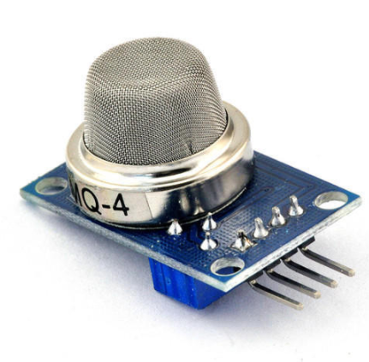
Figure 3.6. MQ4 SENSOR
Connecting five volts across the heating (H) pins keeps the sensor hot enough to function correctly. Connecting five volts at either the A or B pins causes the sensor to emit an analog voltage on the other pins. A resistive load between the output pins and ground sets the sensitivity of the detector.
Here we use the MQ4 sensor for monitoring the gas level of the surroundings where the bot is hovering with the Pi cam relaying the video feed live.

Table 3.2. Summary of Sensor specification
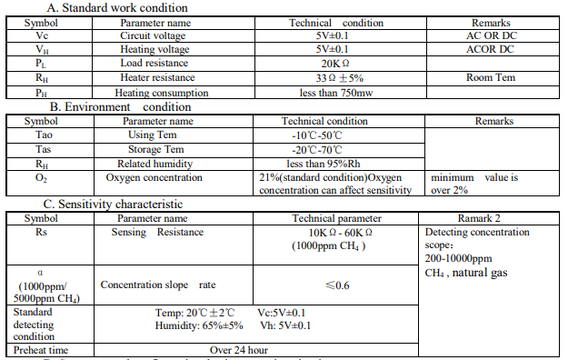

3.2.2.3. MOTOR DRIVER L298N
The L298N is an integrated monolithic circuit in a 15- lead Multiwatt and PowerSO20 packages. It is a high voltage, high current dual full-bridge driver de-signed to accept standard TTL logic level sand drive inductive loads such as relays, solenoids, DC and stepping motors. Two enable inputs are provided to enable or disable the device independently of the in-put signals. The emitters of the lower transistors of each bridge are connected together rand the corresponding external terminal can be used for the connection of an external sensing resistor. An additional Supply input is provided so that the logic works at a lower voltage.
Set IN1 and IN2, confirm the rotational direction of the motor, and then output PWM pulses for enabled terminals. The motor is in the free stop state when the signal of enabled terminal is 0. When the enabled signal is 1, if IN1 and IN2 are 00 or 11, the motor is in brake state, and the motor stops rotating. If IN1 is 0 and IN2 is 1, the motor A rotates clockwise; if IN1 is 1 and IN2 is 0, the motor A rotates counterclockwise. This is the control method for motor A. The control method for motor B is the same as that for motor A.

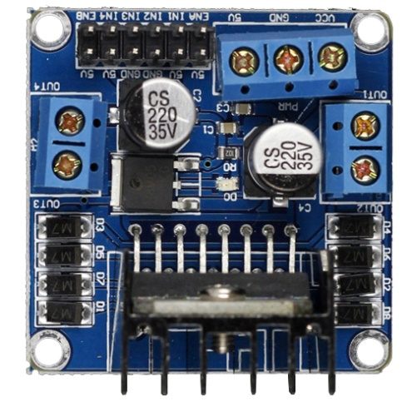
Figure 3.7. L298N MOTOR DRIVER
3.2.2.3. DC MOTORS
These motors are simple DC Motors featuring gears for the shaft for obtaining the optimal performance characteristics. They are known as Center Shaft DC Geared Motors because their shaft extends through the center of their gear box assembly.
These standard size DC Motors are very easy to use. Also, you don’t have to spend a lot of money to control motors with an Arduino or compatible board. TheL298N H-bridge module with onboard voltage regulator motor driver can be used with this motor that has a voltage of between 5 and 35V DC.
This DC Motor – 200RPM – 12Volts can be used in all-terrain robots and a variety of robotic applications. These motors have a 3 mm threaded drill hole in the middle of the shaft thus making it simple to connect it to the wheels or any other mechanical assembly. Nut and threads on the shaft to easily connect and internally threaded shaft for easily connecting it to the wheels. These DC Geared motors with robust metal/Plastic gearbox for heavy-duty applications, available in the wide RPM range and ideally suited for robotics and industrial applications.
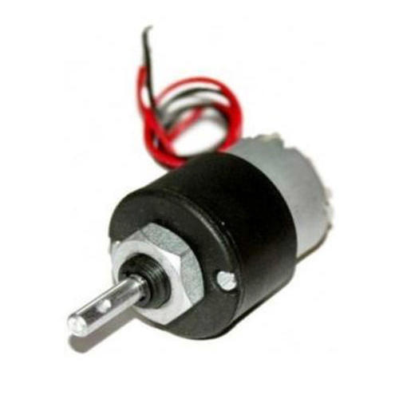
Figure 3.8. DC MOTOR
3.4. SOFTWARE COMPONENTS
The proposed system works around an ESP8266 NODEMCU that is programmed using the Arduino IDE. The NODEMCU is coded in such a way that it controls and retrieves data from the sensor. It pushes the received data to the app from there. The respective libraries are downloaded and are installed to get access over the sensors.
Libraries Used:
- ESP8266WiFi.h
3.5 Code
The code snippets are being discussed as follows.
String i;
int Pin_D7 = 13; //pin D7
int Pin_D8 = 15; //pin D8
int value1;
int value2;
WiFiServer server(80);
void setup()
{
i = "";
Serial.begin(115200);
pinMode(16, OUTPUT);
pinMode(5, OUTPUT);
pinMode(4, OUTPUT);
pinMode(0, OUTPUT);
pinMode(Pin_D7,OUTPUT);
pinMode(Pin_D8,OUTPUT);
pinMode(A0,INPUT);
WiFi.disconnect();
delay(300);
Serial.println("Start Connection");
WiFi.begin("wifi_name","wifi_pass");
while ((!(WiFi.status() == WL_CONNECTED))){
delay(300);
Serial.print("... ");
}
Serial.println("Connected");
Serial.println((WiFi.localIP()));
server.begin();
}
The above snippet describes all the variables used and initiates the WiFi connection with the hotspot that has been set.
void loop()
{
WiFiClient client = server.available();
if (!client) { return; }
while(!client.available()){ delay(1); }
i = (client.readStringUntil('\r'));
i.remove(0, 5);
i.remove(i.length()-9,9);
Serial.println(i);
if (i == "W") {
digitalWrite(16,LOW);
digitalWrite(5,HIGH);
digitalWrite(4,LOW);
digitalWrite(0,HIGH);
}
if (i == "A") {
digitalWrite(5,LOW);
digitalWrite(16,LOW);
digitalWrite(0,HIGH);
digitalWrite(4,LOW);
}
if (i == "S") {
digitalWrite(5,LOW);
digitalWrite(16,HIGH);
digitalWrite(0,LOW);
digitalWrite(4,HIGH);
}
if (i == "D") {
digitalWrite(5,HIGH);
digitalWrite(16,LOW);
digitalWrite(0,LOW);
digitalWrite(4,LOW);
}
if (i == "X") {
digitalWrite(16,LOW);
digitalWrite(5,LOW);
digitalWrite(4,LOW);
digitalWrite(0,LOW);
}
if (i == "R") {
digitalWrite(16,LOW);
digitalWrite(5,HIGH);
digitalWrite(4,HIGH);
digitalWrite(0,LOW);
}
if (i == "L") {
digitalWrite(16,HIGH);
digitalWrite(5,LOW);
digitalWrite(4,LOW);
digitalWrite(0,HIGH);
}
if (i == "T") {
digitalWrite(Pin_D7,HIGH);
delay(100);
Serial.println("Analog senssor value 1 : ");
value1 = analogRead(A0);
Serial.println(value1);
client.println("HTTP/1.1 200 OK");
client.println("Content-Type: text/html");
client.println("");
client.println("<!DOCTYPE HTML>");
client.println("<html>");
client.println(value1);
client.println("</html>");
//client.stop();
delay(1);
digitalWrite(Pin_D7, LOW);
delay(100);
}
if (i == "H") {
digitalWrite(Pin_D8,HIGH);
delay(100);
Serial.println("Analog senssor value 2 : ");
value2 = analogRead(A0);
Serial.println(value2);
client.println("HTTP/1.1 200 OK");
client.println("Content-Type: text/html");
client.println("");
client.println("<!DOCTYPE HTML>");
client.println("<html>");
client.println(value2);
client.println("</html>");
//client.stop();
delay(1);
digitalWrite(Pin_D8, LOW);
delay(100);
}
}

The above code retrieves all the sensor data and also determines the motion of the bot. It also pushes the data to the android app. All the process takes place in a loop. Various variables are declared and are assigned to the respective values that could retrieve and display the data in the android application that has been built for an operation specific purpose of controlling the bot and also viewing the sensor data .

CHAPTER 4
EXPERIMENTAL SETUP AND RESULTS
4.1 INTRODUCTION
This chapter deals presents the details working of the proposed module which is cited in the circuit diagram is specified in the following sections.
4.2 IMPLEMENTATION
The inspection robot has two sub systems - The Wi-Fi Module for navigation & Sensor data acquisition and the Raspberry Pi - Camera setup for video streaming purposes.
The robot chassis is modelled for a six-wheel drive. The chassis is then integrated with high torque motors with low rotations per minute. The motors are then connected to a motor driver circuit. Comparisons were made between L293D motor driver and L298N motor driver. L298N motor driver is preferred because of its ability to handle more current. The potential drop across the motor driver amounts to about 1.5V and this is bearable for our requirements.
The ESP8266 NodeMCU is then integrated along with the motor driver circuit and Wi-Fi commands are tested over the local server. An Android application is developed using MIT App Inventor using the TCP standards for the remote control of the robot.
A Raspberry Pi model 3-B is preferred over the Beagle Board variants due to the ease of access to the Raspberry Pi. UV4L UDP package available for Raspberry Pi is used to stream the video live on to the local server. This video stream is received and viewed on any browser window from a node in the same network. This video quality and frame rate is dynamic and can be varied.
The gas values are acquired from the sensor and displayed on the android application developed for the operation specific purpose.
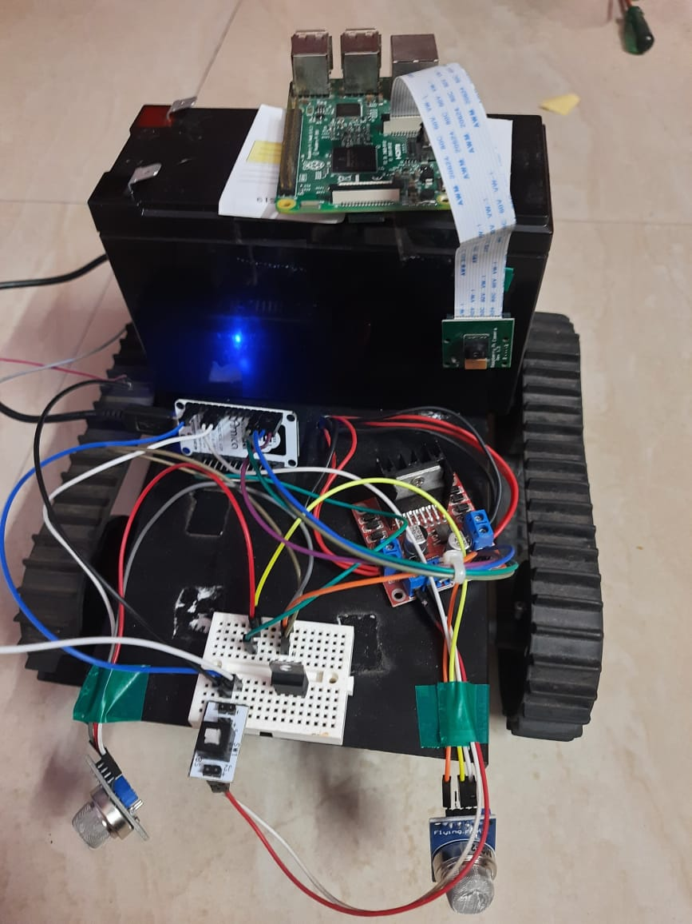
Figure 4.1. Full System Model
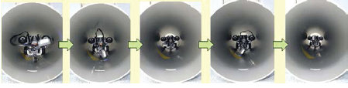
Figure 4.2 PIR during pipeline inspection process

4.2.1. CHASSIS SETUP:
A continuous track belt sturdy setup is used for the purpose of outdoor navigation. Four DC motors, 200 rpm and 10kgcm torque, are used for supporting the system. The motors are powered by a 12V Lead Acid battery. The setup also contains a H-bridge circuit, which aligns the control of the microcontroller with the turning and navigation of the wheels. The H-bridge circuit is primarily an L298N chip connected to a heat sink. It is interfaced to the microcontroller, which provides the input to be fed to the motors and thus controls the motion of the robot. The bot is controlled by the user using the android application.
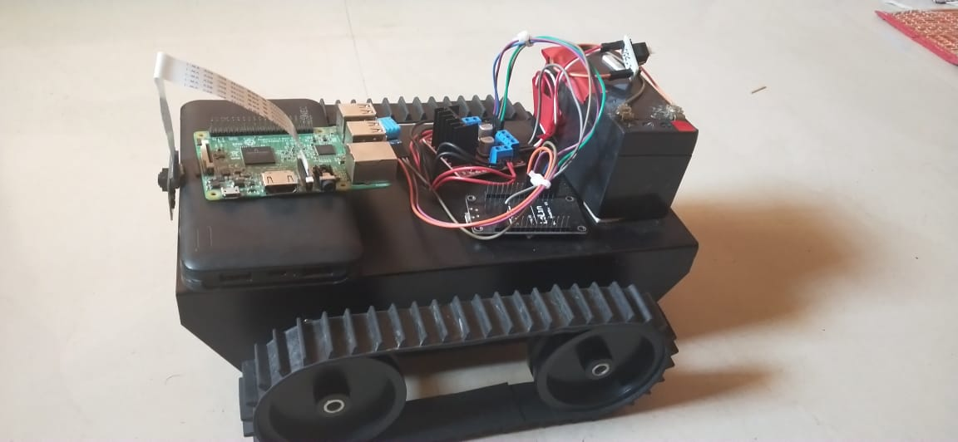
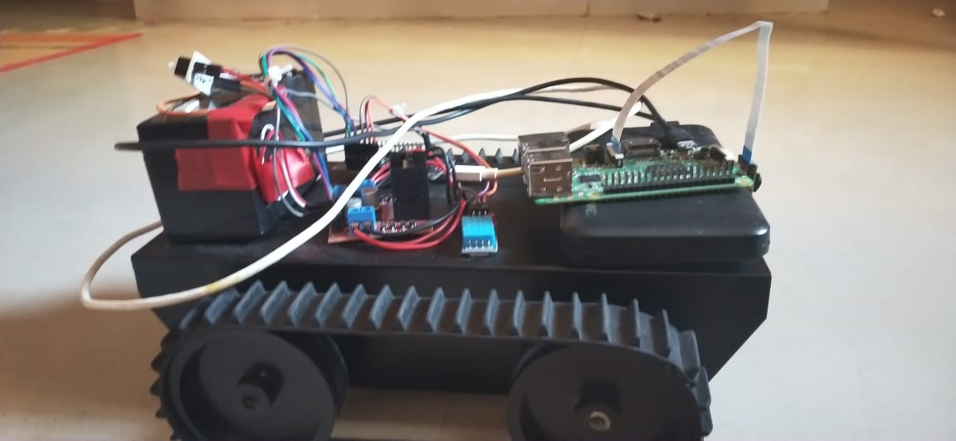

Figure 4.3. Side View of the Full System Model
The special continuous track belt allows the bot to be maneuvered at very difficult and hard to move terrains. This feature permits it to be hovered at unmanned areas easily.
4.2.2. SYTEM INTEGRATION:
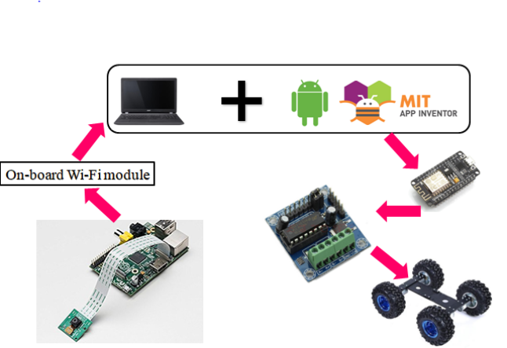
Figure 4.4. System Integration
The system is integrated with several components together as a single ultimate system that proves to be highly efficient. The various components that are used in this project and their working is discussed in this section. Given above is the block diagram of the proposed model.

4.2.3. ANDROID APP:
An android app for the specific operations of operating the bot and retrieving the data from the sensor along with the calculating the distance travelled by the bot from point A to B. This allows the bot to survey the lands and plot the distances easily. This solves the purpose of building the proposed bot.

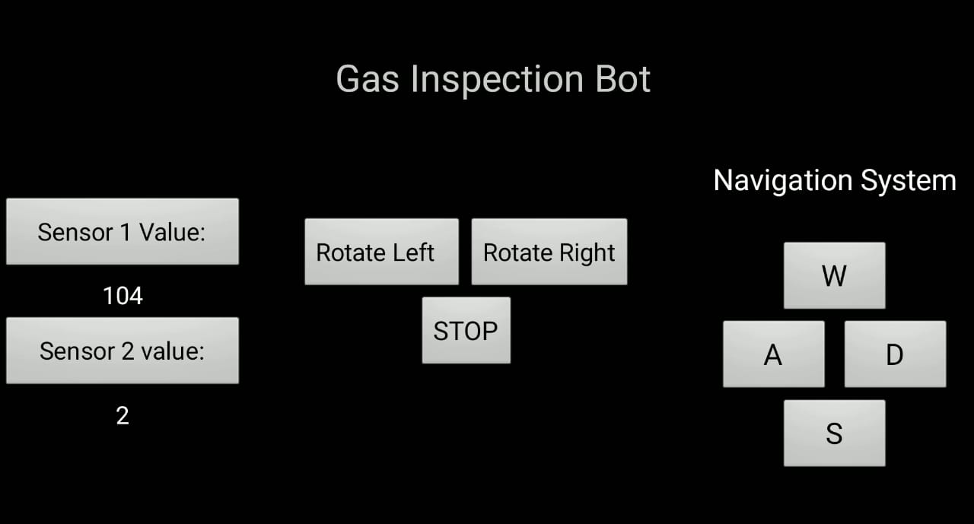
Figure 4.5. Android Application

4.3. RESULT
A Real Time gas inspection robot that could traverse tunnels with a live video stream was constructed and tested. An Android application as User Interface to control the robot's navigation based on the video stream, was rendered as seen in the figure. A compact device within a casing was created.

CHAPTER 5
CONCLUSION AND FUTURE SCOPE
5.1 CONCLUSION
In this chapter the software description and the screen shots of the proposed works are discussed here.
The risk factor involved in exploring tunnels is as high as exploring a damaged building. In such scenarios, human life is always in danger. There is still a huge number of harmful gases present in certain region of tunnels. Thus, the focus is on reducing this risk factor by building a robot which will scout the required region based on our instructions and give us the required data. In this paper, a miniaturized gas inspection bot with a durable design is proposed. The implementation of this design enables the robot to detect harmful gases inside the tunnel and navigate to any region of tunnels and pipes with ease.The aim is to build an android app to control the navigation system of the robot using a Wi-Fi module and a live stream video footage from the integrated camera on the bot. This enables remote navigation of the robot inside the tunnels eliminating the risk factors. The gas sensors provide accurate distribution of various gases inside the tunnels, thus helping in better maintenance. The ‘Inspection robot’ effectively reduces complexity and power consumption issues.
The PIR is a remote controlled, mobile video capturing robot. The focus of this project was to design and implement a robust chassis with Wi-Fi enabled remote control system with a microprocessor and a camera mounted on it. The L298N motor shield provides the appropriate H-bridge circuit for moving the wheels, which perform the actual movement. The PIR is controlled using an Android application on a smart phone.
The Inspection robot is aimed at navigating through pipelined and tunnels which are risky to humans. It can be used in biologically hazardous areas to gather data, aiding scientific research and control. It can also be used during archaeological expedition to preview the nature of any newly excavated area before sending human personnel in, hence ensuring safety of the staff. It could also find application in disaster mitigation and general exploration.
5.2. FUTURE SCOPE
This project can be improved by implementing GPS based automated navigation. Control of the device by a voice recognition system. The mobile bot can be made autonomous. Thermal cameras can be integrated for surveillance purpose. UV or color sensors can be attached to the bot which is used for crack detection. In order to be controlled from anywhere around the globe, port forwarding mechanism can be implemented and this bot can have a very superior power of a rover kind of bot. This could prove very useful for large diameter tunnels and pipes.

REFERENCES
- Shahdib F, Bhuiyan MWU, Hasan MK, Mahmud H.,(2013), ‘Obstacle detection and object size measurement for autonomous mobile robot using sensor’. Int J Comput Appl, Vol.66, No.9.
- Yu, S. et al.: Auto inspection system using a mobile robot for detecting concrete cracks in a tunnel. Automation in Construction, 16 (3), p. 255–261, 2007.
- Lee, S.Y. et al.: Development of an inspection system for cracks in a concrete tunnel lining. Canadian Journal of Civil Engineering, 34 (8), p. 966–975, 2007.
- Ko, B. et al.: Development of an Inspection System for Cracks on the Lining of Concrete Tunnels. In: Proceedings of the 20th ISARC. Eindhoven, Holland, 2003, p. 457–463.
- K. Keshamoni and S. Hemanth, "Smart Gas Level Monitoring, Booking & Gas Leakage Detector over IoT," 7th International Advance Computing Conference (IACC), Hyderabad, July 2017.
- H. H. Yan and Y. Rahayu, “Design and Development of Gas Leakage Monitoring System using Arduino and ZigBee,” Proceeding of International Conference on Electrical Engineering, Computer Science and Informatics (EECSI 2014), Yogyakarta, Indonesia, August 2014.
- H. Supriyono and A.N. Hadi, "Designing a wheeled robot model for flammable gas leakage tracking," Second International Conference on Informatics and Computing (ICIC), Jayapura, Indonesia, Nov 2017.
- M.M. Almasri, K.M. Elleithy and A.M. Alajlan, "Development of efficient obstacle avoidance and line following mobile robot with the integration of fuzzy logic system in static and dynamic environments," Long Island Systems, Applications and Technology Conference (LISAT), New York, USA, April 2016.
- T.F. Wu, P.S. Tsai, N.T. Hu and J.Y. Chen, "Use of Ultrasonic Sensors to Enable Wheeled Mobile Robots to Avoid Obstacles," Tenth International Conference on Intelligent Information Hiding and Multimedia Signal Processing, Kitakyushu, Japan, August 2014.
- Dr. Kaushika Patel, Raj Kevadiya, Shreya Maheta. “Fault Detection for Underground Cable”. International Journal of Advanced Engineering and Research (Volume 5, Issue 01, January -2018) e-ISSN (O): 2348-4470 p-ISSN (P): 2348-6406.
- Soubia Noorain, Mamtha M, Zohra Jabeen. “Underground cable fault detection using a robot”. International Research Journal of Engineering and Technology (IRJET) (Volume: 05 Issue: 05 | May-2018) eISSN: 2395-0056 p-ISSN: 2395-0072.
- Zhu Jianguo, Gao Junyao, Li Kejie, Lin Wei and Bi Shengjun, "Embedded control system design for coal mine detect and rescue robot,”2010 3rd International Conference on Computer Science and Information Technology”, Chengdu, China, 2010, pp. 64-68, doi: 10.1109/ICCSIT.2010.5563599.
- G. K. Dey, R. Hossen, M. S. Noor and K. T. Ahmmed, "Distance controlled rescue and security mobile robot," 2013 International Conference on Informatics, Electronics and Vision (ICIEV), Dhaka, Bangladesh, 2013, pp. 1-6, doi: 10.1109/ICIEV.2013.6572602.

- Canny J. A computational approach to edge detection (1986), ,IEEE Trans Pattern Anal Mach Intell.
- Yan J., (2008), ‘Infrared sensor’, U.S. Patent 7,408,157.
- Forino C. Play embedded. (2016) [Online] Available at: www. playembedded.org/blog/en/2016/01/08/detecting-obstacle-with-ir- nsorand-arduino.
- Matsuo K. (2010)Murata manufacturing Co., Ltd. ‘Ultrasonic sensor’, U.S. Patent 7,728,486.
- King T. ArduinoInfo. (2017), ‘www.arduino-info. wikispaces/ Ultrasonic Distance’.
- Skiena S., (1990), ‘Dijkstra's algorithm. Implementing discrete mathematics’: combinatorics and graph theory with mathematica. Reading, MA: Addison-Wesley; pp. 225-238.
- Shafer A, Turney M, Ruiz F, Mabon J, Paruchuri V, Sun Y., (2016) ‘Robotics based autonomous wheelchair navigation’, J Commun Comput Vol.6 No.13, pp 34-45.
- Kramer J, Scheutz M., (2007) ‘Development environments for autonomous mobile robots: a survey’, Aut Robots, Vol. 22, No.2, pp.101-132.
- https://www.raspberrypi.org/products/raspberry-pi-3-model-b
- J. Paskarbeit, S. Beyer, A. Gucze, J. Schröder, M. Wiltzok, M. Fin-gberg, A. Schneider, "Ourobot-a self-propelled continuous-track-robot for rugged terrain", Robotics and Automation (ICRA) 2016 IEEE International Conference, pp. 4708-4713, 2016.

